ABOUT PRODUCT
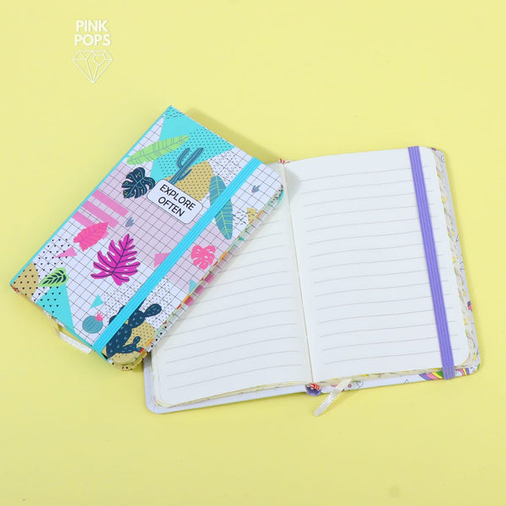
- BEST PERSONAL DIARY JOURNAL NOTE BOOK
- MEDIUM SIZE: 4.2 INCHES X 6 INCHES
- COLORFUL PRINTED PAGES IN IT.
- FINE QUALITY SMOOTH AND SILKY PAGES.
- ATTRACTIVE STYLISH COVER ON IT.
- BEST GIFT PRODUCT FOR YOUR LOVING ONES.
PRICE= RS 599.99

